**East West University**

**Project Title:**

**Implement Bubble Sort Using Assembly Language**

**Group Members**

MijanurRahaman Joy

ID: 2017-2-60-070

SwaksharDebnath

ID: 2017-2-60-034

Efat Ara Minu

ID: 2017-1-60-059

**Abstract:**

Sorting algorithms provide a way to arrange a series of numbers or letters in some predefined order based on some measurable quantity in the numbers or letters. Thus we may arrange a series of numbers according to their values in an increasing order or we may arrange the letters according to decreasing order of their 8085 microprocessor values using sorting. In this paper we will describe a simple and easy to implement sorting algorithm called Bubble Sort.

**Introduction:**

Given a list of n numbers or letters the objective of any sorting algorithm is to arrange the same in a particular order where the ordering is done based on some intrinsic property of the inputs. The simplest way to sort a list of input values is to compare them pairwise and obtain the proper ordering. Sorting algorithms that achieve their goal by comparison are called comparison based sorting algorithm. Bubble Sort is a simple and easy to implement comparison based sorting algorithm. We will describe the algorithm by sorting a list of n numbers in increasing order of magnitude. The same process can be followed to sort a list of letters according to some criteria. The input to the algorithm will be a list of n numbers in a random order and the output will be a list of the same n numbers arranged in an increasing order of magnitude.

**Research:**

8085 Microprocessor**:** 8085 is pronounced as "eighty-eighty-five" microprocessor. It is an 8-bit microprocessor designed by Intel in 1977 using NMOS technology.

It has the following configuration −

* 8-bit data bus
* 16-bit address bus, which can address upto 64KB
* A 16-bit program counter
* A 16-bit stack pointer
* Six 8-bit registers arranged in pairs: BC, DE, HL
* Requires +5V supply to operate at 3.2 MHZ single phase clock

**8085 Microprocessor Architecture:**

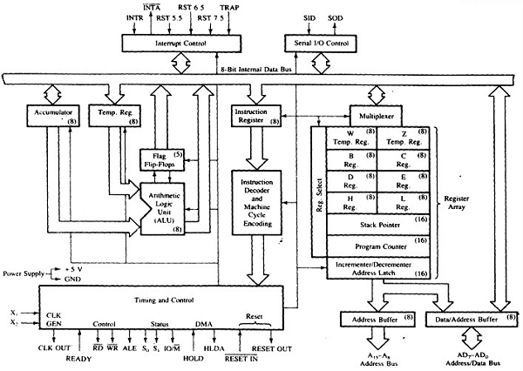

**Fig:** 8085 Microprocessor Architecture

**Propose work:** Sortn-numbers using bubble sort algorithm in 8085 Assembly Language.

**Program Flow chart :**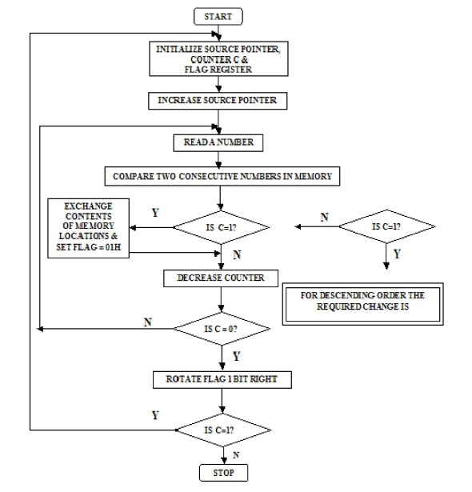

We have used GNUsim8085 simulator to simulate bubble sort. In our program user can choose in which order the elements should be sorted.

**Analysis:**

N numbers will be given. In this program we will arrange the numbers in bubble sorting technique. In this sorting technique, it will be executed in different pass. In each pass the largest number is stored at the end of the list. Here we are taking the numbers from location 0FF6H to onwards. The array size is stored at 0FF5H.

**Result and 8085 Assembly Code:**

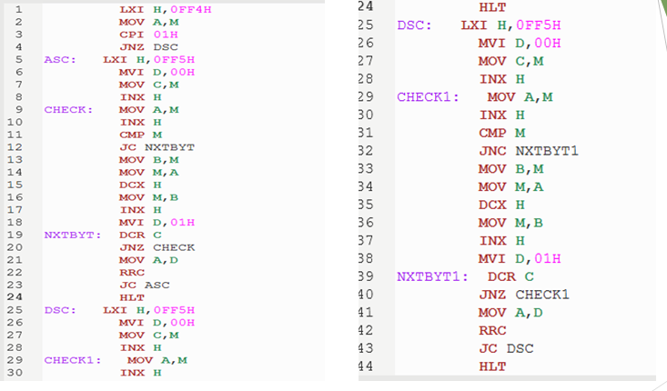

**Output:**

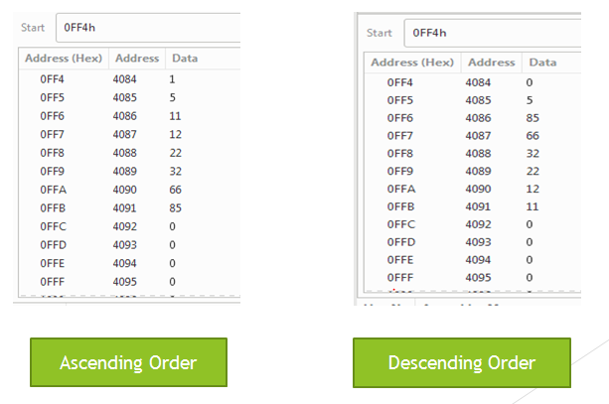

**Limitations:** Our code is not very efficient because bubble itself is not a very efficient algorithm. And our code is a bit messy. May be it could be done with lesser number of instruction sets. We are new in assembly language and this is what we could do with our limited knowledge. We are looking forward to improve it in the near future.

**Conclusion:** Thus, in this article, we have had a look at bubble sort and its working. Furthermore, we optimized the algorithm and learned its implementation in assembly language.

**References:**

[**https://www.tutorialspoint.com/microprocessor/microprocessor_8085_architecture.htm**](https://www.tutorialspoint.com/microprocessor/microprocessor_8085_architecture.htm)

[**https://www.geeksforgeeks.org/8085-program-bubble-sort/**](https://www.geeksforgeeks.org/8085-program-bubble-sort/)